**1.Modelo RF5_Indeg Apoio Levantamento diques cintura X All var**.

***Instrucciones modelo***: **test size = 0.2 ; rd_state = 12**

***Variables indep select to fit***:

variables = ['id', 'Indeg_IntimAmigos_'

, 'Indeg_RedeRisk_Cen','PC1_Distance_Pro',

    'Avg_Distancia_Dist_moranza','Degree_RedeTotFamil',

   '2_VarExp_Atri_Tabanca', 'OutDeg_RedeRisk_Cen', 'OutDeg_RedeConfianc']

***Model performance (scores):***

Mean Squared Error: 1.2308

R^2 Score: 0.467 (In Excel: R2 = 0.5556 ; y = 0.0.3338 X + 0.538 )

**Model tot:**

Mean Squared Error (MSE): 0.4341

Root Mean Squared Error (RMSE): 0.6585

Mean Absolute Error (MAE): 0.3411

R^2 Score: 0.7217

Pearson Correlation: 0.8642

***Interactions***:

| **Interacción** | **Importancia** | **Dirección** |
| --- | --- | --- |
| 0 | (Indeg_RedeRisk_Cen, OutDeg_RedeRisk_Cen) | 0.372315 | 0.110477 |
| 1 | (Indeg_RedeRisk_Cen, 2_VarExp_Atri_Tabanca) | 0.344085 | 0.098818 |
| 2 | (Indeg_RedeRisk_Cen, Degree_RedeTotFamil) | 0.317754 | 0.109752 |
| 3 | (Indeg_RedeRisk_Cen, OutDeg_RedeConfianc) | 0.287079 | 0.098042 |
| 4 | (Indeg_RedeRisk_Cen, Avg_Distancia_Dist_moranza) | 0.253625 | 0.105951 |
| 5 | (Indeg_RedeRisk_Cen, PC1_Distance_Pro) | 0.250794 | 0.103832 |
| 6 | (Indeg_IntimAmigos_, Indeg_RedeRisk_Cen) | 0.240611 | 0.003426 |
| 7 | (2_VarExp_Atri_Tabanca, OutDeg_RedeConfianc) | 0.240170 | 0.271643 |
| 8 | (Degree_RedeTotFamil, OutDeg_RedeRisk_Cen) | 0.239381 | 0.033394 |
| 9 | (OutDeg_RedeRisk_Cen, OutDeg_RedeConfianc) | 0.224246 | 0.048019 |

***Key results****:*

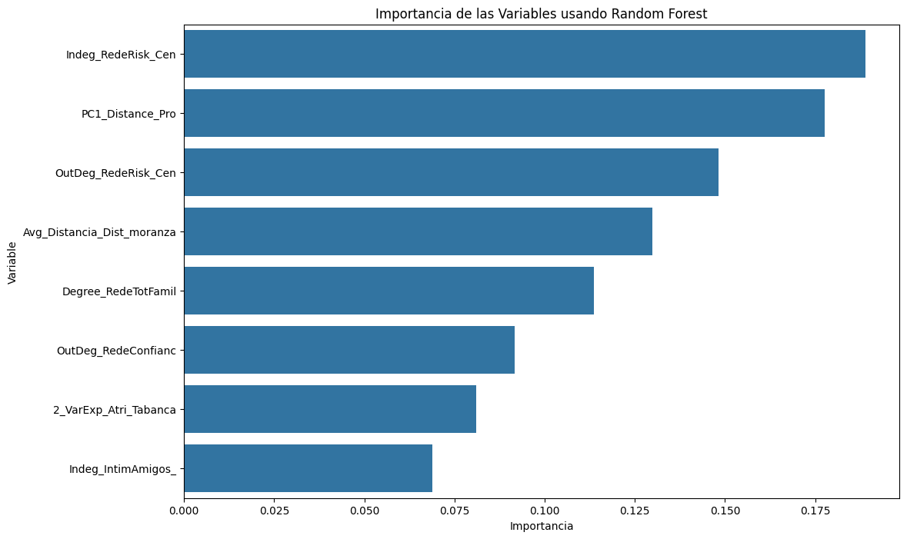

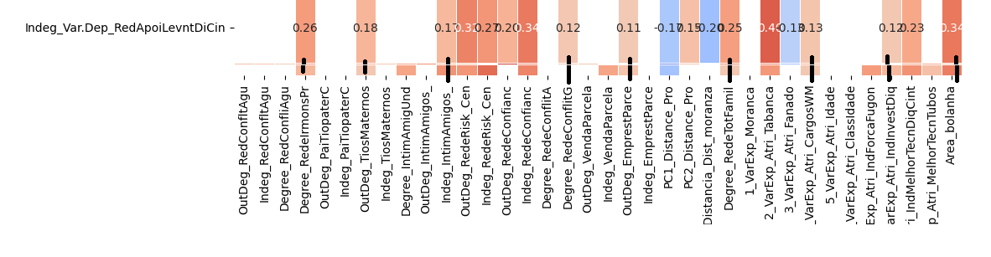

**REV 2.Modelo RF5_Outdeg Apoio Levantamento diques cintura X All var**.

***Instrucciones modelo***: **test size = 0.22 ; rd_st: 9**

***Variables indep select to fit***:

variables = [ 'id', 'Indeg_IntimAmigos_', 'Indeg_RedeRisk_Cen',

    'Indeg_RedeConfianc', 'PC1_Distance_Pro','Avg_Distancia_Dist_moranza',

    'Degree_RedeTotFamil', 2_VarExp_Atri_Tabanca, '2_VarExp_Atri_Tabanca',

4_VarExp_Atri_CargosWM', '7_VarExp_Atri_IndForcaFugon',

'8_VarExp_Atri_IndInvestDiq', '9_VarExp_Atri_IndMelhorTecnDiqCint',

'Area_bolanha','OutDeg_RedeRisk_Cen']

***Model performance (scores):***

Mean Squared Error: 0.5172

R^2 Score: 0.6992 (on excel: **R2= 0.7196 ; Y = 0.6722 X + 0.1328**)

**Model tot:**

Mean Squared Error (MSE):0.2248

Root Mean Squared Error (RMSE):0.4741

Mean Absolute Error (MAE): 0.1938

R^2 Score: 0.8326

Pearson Correlation: 0.9209

***Interactions***:

| **Interacción** | **Importancia** | **Dirección** |
| --- | --- | --- |
| 0 | (Indeg_RedeConfianc, OutDeg_RedeRisk_Cen) | 0.421045 | 0.126750 |
| 1 | (Indeg_IntimAmigos_, Indeg_RedeConfianc) | 0.409097 | 0.054311 |
| 2 | (Indeg_RedeConfianc, 9_VarExp_Atri_IndMelhorTe... | 0.406623 | 0.109603 |
| 3 | (Indeg_IntimAmigos_, 9_VarExp_Atri_IndMelhorTe... | 0.399489 | 0.063356 |
| 4 | (Indeg_RedeConfianc, Degree_RedeTotFamil) | 0.392155 | 0.131732 |
| 5 | (Indeg_RedeConfianc, 4_VarExp_Atri_CargosWM) | 0.386622 | 0.128420 |
| 6 | (Indeg_RedeConfianc, PC1_Distance_Pro) | 0.385259 | 0.127450 |
| 7 | (Indeg_RedeConfianc, 8_VarExp_Atri_IndInvestDiq) | 0.385126 | 0.128024 |
| 8 | (Indeg_RedeConfianc, 2_VarExp_Atri_Tabanca) | 0.384387 | 0.128030 |
| 9 | (Indeg_RedeConfianc, Avg_Distancia_Dist_moranza) | 0.382462 | 0.125857 |

***Key results****:*



